*Multi Car Premium Garage*

**RKS AUT**

[**www.rksauto.in**](http://www.rksauto.in/)

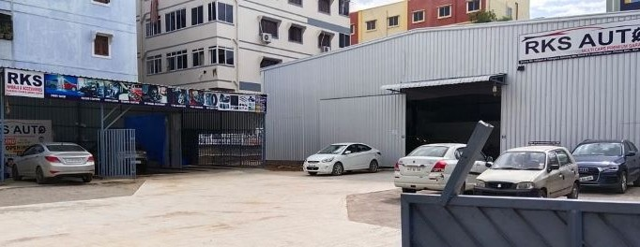

**Address : Survey No : 145/part of Telangana Spinning Mill, Block No : 5, Chandra Nagar, Chintal, IDPL, Hyd, T.S - 37. Landmark : Beside MPR Complex (Bhagyaradhi Degree College)**

**Opp. Vijaya Diagnostic Center, Near IDPL Cross Road Main Road.**

#### 988537138, 9966175257

**Limited Period Only**

#### We have fully equipped with latest electronic & computerized

**Dear Customer,**

**equipments & also complete body & paint repair systems to make your car perfect.**



**OUR SERVICES**

##### CAR REPAIRS GENERAL SERVICE BODY & PAINT

**A/C & ELECTRICAL SERVICE PROGRAMMINGS**



##### UV (TEFLON COATING) FOAM WASH

**INTERIOR SHAMPOO CLEANING INSURANCE CLAIMS(REPAIRS) INSURANCE RENEWAL**

##### CAR ACCESSORIES MULTI BRAND TYRES WHEEL ALIGNMENT WHEEL BALANCING

**TYRE PUNCTURES & NITROGEN**

      



**PICKUP**

**& DROP FREE**

**Facility Only For Paid Service (Upto 5 Kms)**

**TIMINGS :- 9:30 AM to7:30 PM**

**\*SUNDAY CLOSED**

## WASHING OFFER

As a Premium Customer Get

4 Times Car Wash

**ABSOLUTELY FREE**

## SCANNING OFFER

As a Premium Customer Get

2 Times Car Scanning

#### ABSOLUTELY FREE

## INTERIOR OFFER

As a Premium Customer Get

1 Time 50% Discount

**INTERIOR**

**SHAMPOO CLEANING**

## WHEEL CARE

As a Premium Customer Get

2 Times Wheel Alignment

#### ABSOLUTELY FREE

**A/C CHECKUP OFFER**

As a Premium Customer Get

2 Times AC Checkup

#### ABSOLUTELY FREE

## PAINTING OFFER

As a Premium Customer Get

1 Time 5000/- Off On

#### Full Body Painting

**GENERAL CHECKCUP OFFER**

As a Premium Customer Get

2 Times General Checkup

**ABSOLUTELY FREE**

**TEFLON COATING OFFER**

As a Premium Customer Get

1 Time 50% Discount On

### TEFLON COATING

**PAID SERVICE OFFER**

As a Premium Customer Get 1st Time 25% and 2nd Time 50% Discount

On **Labour Charges Only**

# FOAM WASH BAY WHEEL ALIGNMENT BAY

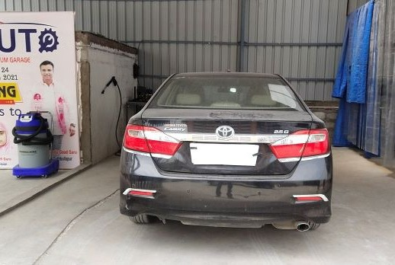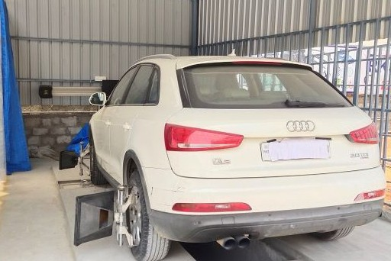

|  |  |  |  |  |  |
| --- | --- | --- | --- | --- | --- |
| WASHING OFFER  FREE  **CAR WASH**  **Valid For 2023** | WASHING OFFER  FREE  **CAR WASH**  **Valid For 2023** | WHEEL CARE  FREE  WHEEL  ALIGNMENT  **Valid For 2023** | GENERAL OFFER  FREE  GENERAL  CHECKUP  **Valid For 2023** |  | **GET**  **For First Paid Service OFF** |
| WASHING OFFER  FREE  **CAR WASH**  **Valid For 2023** | WASHING OFFER  FREE  **CAR WASH**  **Valid For 2023** | WHEEL CARE  FREE  WHEEL  ALIGNMENT  **Valid For 2023** | GWEANSEHRIANLG OOFFFFEERR  FREE  GENERAL  CHECKUP  **Valid For 2023** |



25%

WELCOME OFFER

**On Labour Charges Only**

QUICK REPAIR BAY SERVICE BAY

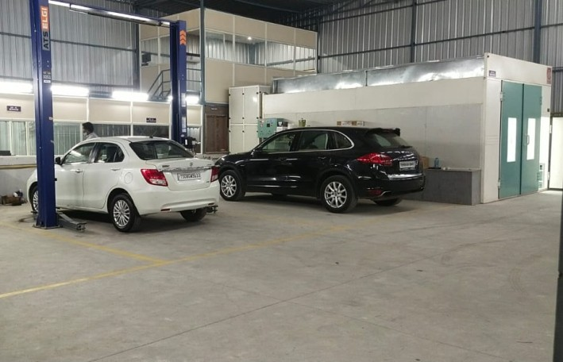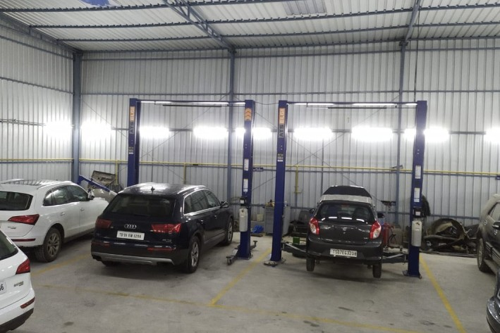

|  |  |  |  |  |  |
| --- | --- | --- | --- | --- | --- |
| 2nd PAID SERVICE  **GET**  50%  Discount  **On**  **(Labour Charges Only)** | GOLDEN OFFER  **GET**  50%  Discount  **TEFLON COATING**  **One Time** | SCANNING OFFER  FRCAER E  SCANNING  **Valid For 2023** | AC CHECKUP  FREE  AC  CHECKUP  **Valid For 2023** |  | **Reference Offer**  **GET**25%  **ONE**  **TIME OFF**  **ON FIRST PAID SERVICE**  **(On Labour Charges Only)**  S.No.  My Friend Name...................................  ..............................................................  Mobile No..............................................  Vehicle No.............................................  Chasis No..............................................  Get 25% Discount on General Service on customer vehicle. |
| PAINTING OFFER  **GET**  5000/-  OFF  **On Full Body Painting One Time** | GOLDEN OFFER  **GET**  50%  Discount  **INTERIOR SHAMPOO CLEANING**  **One Time** | SCANNING OFFER  FREE  CAR  SCANNING  **Valid For 2023** | AC CHECKUP  FREE  AC  CHECKUP  **Valid For 2023** |



# CUSTOMER LOUNGE

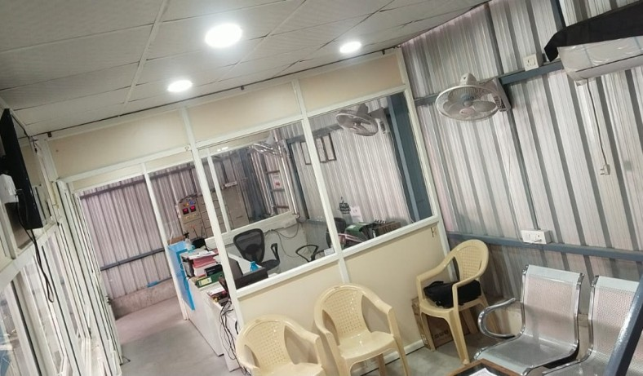

PAINT BOOTH

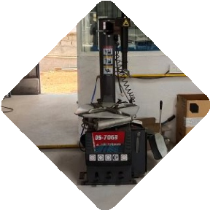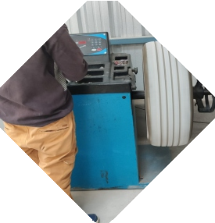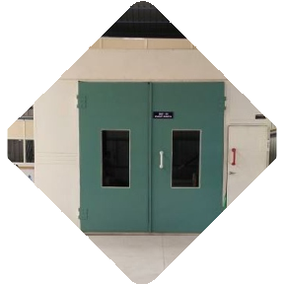

TYRE CHANGE

WHEEL BALANCING

**S.No.**

Name Address

Contact No. Veh. Reg No. VIN No.

Model Colour Date of issue Sales Manager Mobile No.

I have understood & agree all the T&C.

**Amount Paid Rs.**

Signature

of the customer

**S.No.**

Name Address

Contact No. Veh. Reg No. VIN No.

Model Colour Date of issue Sales Manager Mobile No.

I have understood & agree all the T&C.

**Amount Paid Rs.**

Signature

of the customer

**S.No.**

Name__________________________________

Address ________________________________

_______________________________________ Contact No. _____________________________ Veh. Reg No.____________________________ Model__________________________________ Date of issue ____________________________ Field Manager ___________________________ I have understood & agree all the T&C.

**Signature of the customer**

**S.No.**

Name__________________________________

Veh. Reg No.____________________________

Model & Colour __________________________

Date of issue ____________________________

Field Oﬃcer _____________________________

Mobile__________________________________

I have understood & agree all the T&C.

**Signature of the customer**

**RKS AUT**

**Anniversary**

*Multi Car Premium Garage*

**1499/-**

**Offer**

**Existing New**



**TERMS & CONDITIONS**

**1.**

Valid for RKS Auto Only.

1. Valid for **18** Months from the date of issue.
2. Premium card is non - refundable/lost card will not be replaced.
3. While giving your vehicle for servicing, please present

the premium card and the relevant coupon to the service advisor.

1. This card is valid for registered vehicle only and

coupon cannot be used for the other vehicle.

1. Please book your vehicle in advance for Servicing & Repairing, If not Coupon does not valid.
2. Customer can use maximum two coupons per visit

Oral commitments not accepted.

1. For any parts to be replaced will be charged Cash and Carry Taxes as applicable.
2. Terms & Conditions Apply in case of any disputes **RKS AUTO**

management decision is ﬁnal and binding.



Pulse Hospital Road

**SBI Bank**

Lalitha Hospital Road

**Airtel Store**

**IOC Petrol Pump**

**Bajaj Electronics**

**Balanagar Road**

**IDPL Junction**

**Jeedimetla Road**

**IOC Petrol Pump**

*Multi Car Premium Garage*

**RKS AUT**

**Domino’s Pizza**

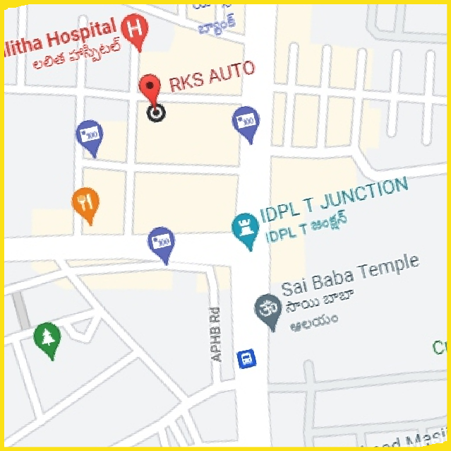

**SBI Bank**

**Jeedimetla Road**

**IDPL Junction**

**Balanagar Road**

**IOC Petrol Pump Bajaj**

**JAGADGIRIGUTTA ROAD**

**MPR Convention**

**Vijaya Diagnostics**

**JAGADGIRIGUTTA ROAD**

**IOC Petrol Pump**

**National Highy**

**National Highy**

*Multi Car Premium Garage*

**RKS AUT**

##### For More Information about Premium Card

**Please Call : 9491727356**

**LOCATION**

**\*To avoid**

**Address : Survey No : 145/part of Telangana Spinning Mill, Block No : 5, Chandra Nagar, Chintal, IDPL, Hyd, T.S - 37. Landmark : Beside MPR Complex (Bhagyaradhi Degree College)**

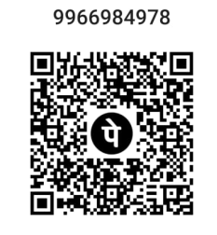

**Opp. Vijaya Diagnostic Center, Near IDPL Cross Road Main Road.**

    



**in convenience of service Please take prior One day appointment (Mandatory).**

Compaign done by

**SWARNAM**

**For More Information about Premium Card**

**Please Call : 9491727356,**



**JSR Printers Cell : 9000794199**